**PRACTICAL 3.1**

# PRACTICAL-3

**Aim:** Create simple Application which show the use of List view.

## Design:

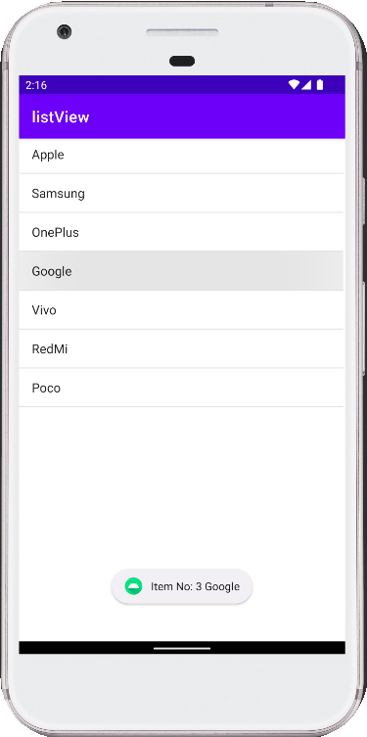

**Input (Java Code):**

package com.example.practical_3_1;

import androidx.appcompat.app.AppCompatActivity; import android.os.Bundle;

import android.view.View;

import android.widget.AdapterView; import android.widget.ArrayAdapter; import android.widget.ListView; import android.widget.Toast;

import java.util.ArrayList;

public class MainActivity extends AppCompatActivity { ListView lv;

String phn[] = {"Apple","Samsung","OnePlus", "Google", "Vivo", "RedMi", "Poco"}; @Override

protected void onCreate(Bundle savedInstanceState) { super.onCreate(savedInstanceState); setContentView(R.layout.activity_main);

lv = findViewById(R.id.listView);

ArrayAdapter arrayAdapter = new ArrayAdapter(this, android.R.layout.simple_list_item_1,phn);

lv.setAdapter(arrayAdapter);

lv.setOnItemClickListener(new AdapterView.OnItemClickListener() { @Override

public void onItemClick(AdapterView<?> adapterView, View view, int i, long l) {

Toast.makeText(MainActivity.this,"Item No: "+i+ " "+lv.getItemAtPosition(i).toString(), Toast.LENGTH_SHORT).show();

}

});

}

}

## Output:

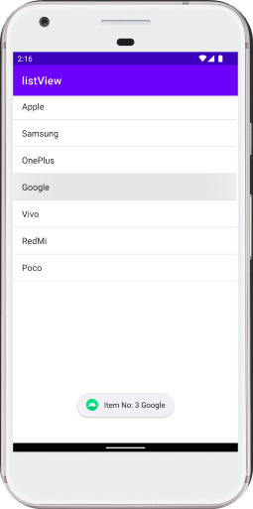

**Conclusion:** In this practical, we learnt about how to use list view in our activity. We also came across new terms like set On Click Listener of every particular list item and how to display messages on click of the button using Toast.

## PRACTICAL 3.2

**Aim:** Create simple program which show the use of Auto Complete Text View.

## Design:



**Input (Java Code):**

package com.example.practical_3_2;

import androidx.appcompat.app.AppCompatActivity; import android.os.Bundle;

import android.widget.ArrayAdapter;

import android.widget.AutoCompleteTextView;

public class MainActivity extends AppCompatActivity {

String a[] = {"Allbania", "Afghanistan", "Antofagesta", "Angola", "Australia","Austria"}; AutoCompleteTextView actv;

@Override

protected void onCreate(Bundle savedInstanceState) { super.onCreate(savedInstanceState); setContentView(R.layout.activity_main);

actv = findViewById(R.id.autoCompleteTextView); ArrayAdapter<String> adapter = new ArrayAdapter<String>(this,

android.R.layout.simple_list_item_1,a);

actv.setAdapter(adapter);

}

}

## Output:

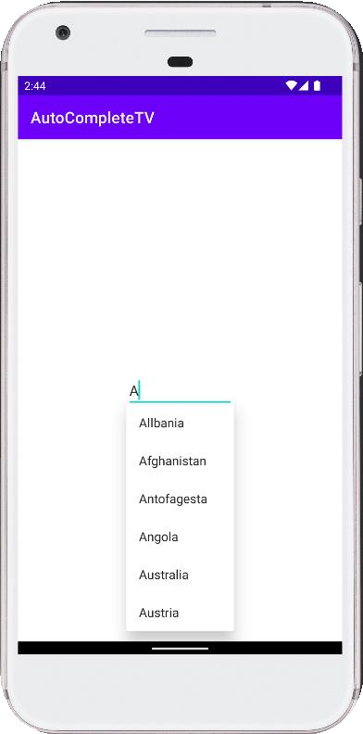

**Conclusion:** In this practical, we learned about Auto Complete text View and how to use it for auto suggestion of words.

## PRACTICAL 3.3

**Aim:** Create simple application which shows use of radio view, take 3 radio buttons. When radio button is selected it will show text of radio button using toast.

## Design:

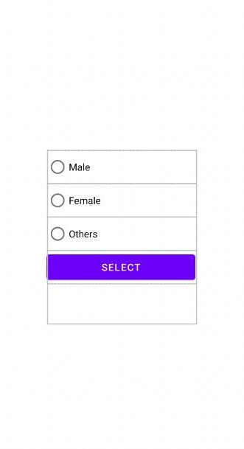

**Input (Java Code):**

package com.example.practical_3_3;

import androidx.appcompat.app.AppCompatActivity; import android.os.Bundle;

import android.view.View; import android.widget.Button;

import android.widget.RadioButton; import android.widget.RadioGroup; import android.widget.Toast;

public class MainActivity extends AppCompatActivity { RadioGroup rg;

RadioButton rb1,rb2,rb3,rb; Button btn1;

@Override

protected void onCreate(Bundle savedInstanceState) { super.onCreate(savedInstanceState); setContentView(R.layout.activity_main);

rg = findViewById(R.id.radiogrp);

rb1 = findViewById(R.id.radioButton); rb2 = findViewById(R.id.radioButton2); rb3 = findViewById(R.id.radioButton3); btn1 = findViewById(R.id.button);

rg.setOnCheckedChangeListener(new RadioGroup.OnCheckedChangeListener() { @Override

public void onCheckedChanged(RadioGroup radioGroup, int i) { rb = findViewById(i);

Toast.makeText(MainActivity.this, rb.getText(), Toast.LENGTH_SHORT).show();

}

});

btn1.setOnClickListener(new View.OnClickListener() { @Override

public void onClick(View view) { if(rb1.isChecked())

Toast.makeText(MainActivity.this, rb1.getText(), Toast.LENGTH_SHORT).show();

else if(rb2.isChecked()) Toast.makeText(MainActivity.this, rb2.getText(),

Toast.LENGTH_SHORT).show(); else if(rb3.isChecked())

Toast.makeText(MainActivity.this, rb3.getText(), Toast.LENGTH_SHORT).show();

}

});

}

else

Toast.makeText(MainActivity.this, "Select appropriate Option", Toast.LENGTH_SHORT).show();

}

## Output:

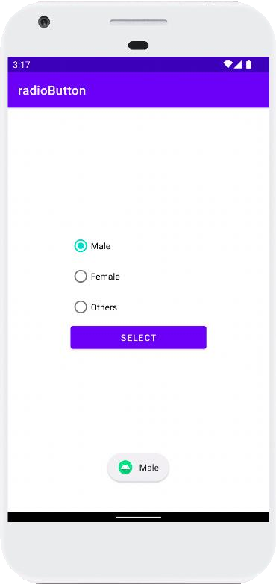

**Conclusion:** In this practical, we learned about Radio Group and Radio Button along side with their implications.